**VIDHI ROHIRA**

**SY BTECH**

**COMPUTER ENGINEERING**

**DAA LAB 4**

**OUTPUTS**

**231071052**

**10-DIGIT-NUMBER**

**TEST CASE 1:-**

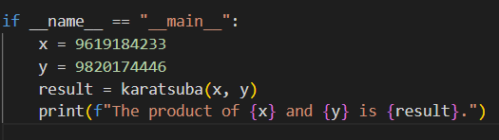



**TEST CASE 2:-**

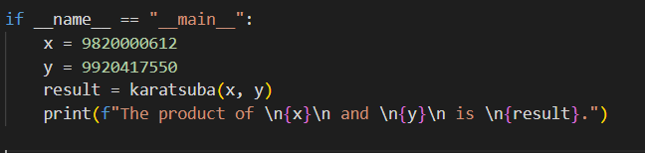

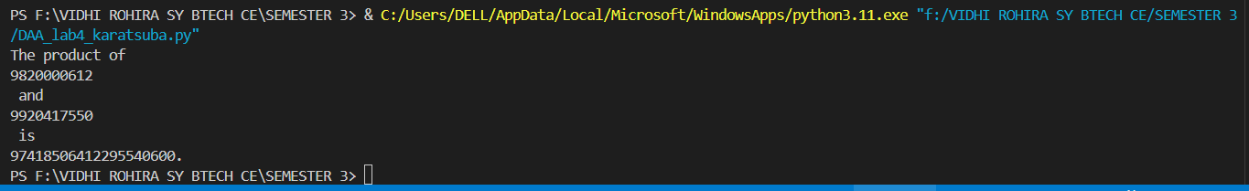

**50-DIGIT-NUMBER**

**TEST CASE 3:-**

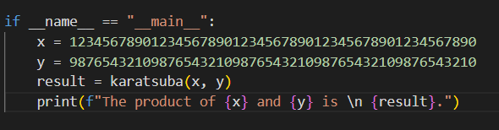



**TEST CASE 4:-**

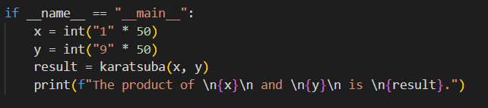

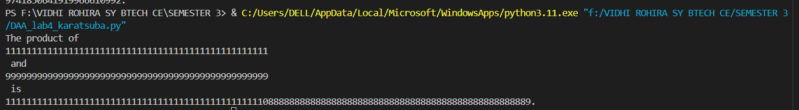

**100-DIGIT-NUMBER**

**TES CASE 5:-**

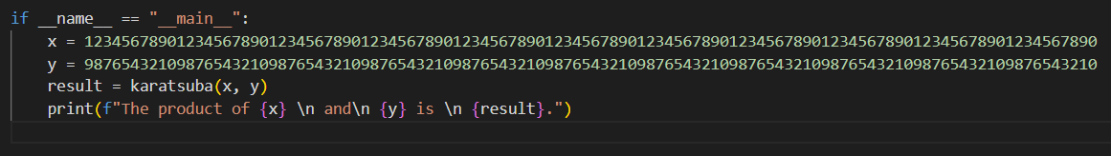

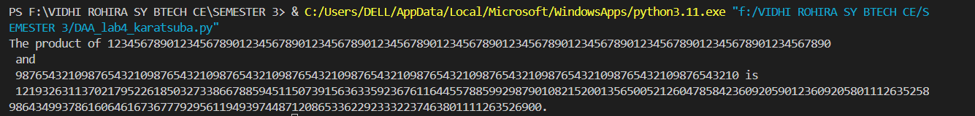

**TEST CASE 6:-**

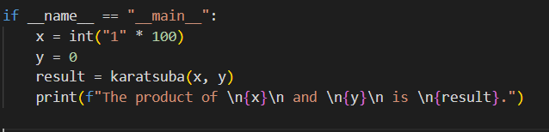

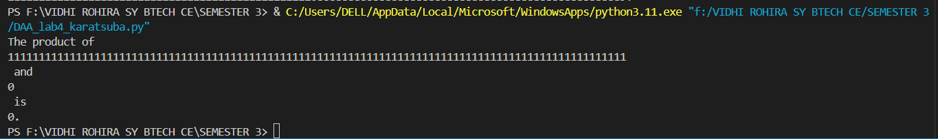

**500-DIGIT-NUMBER**

**TEST-CASE 7:-**

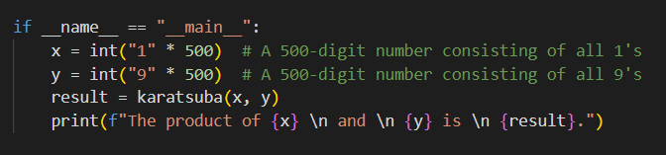

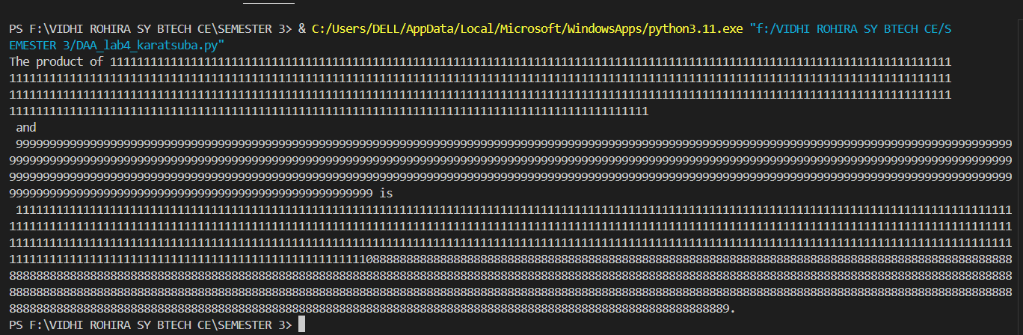

**TEST CASE 8:-**

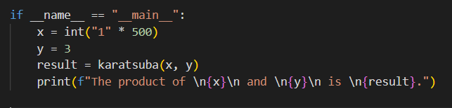

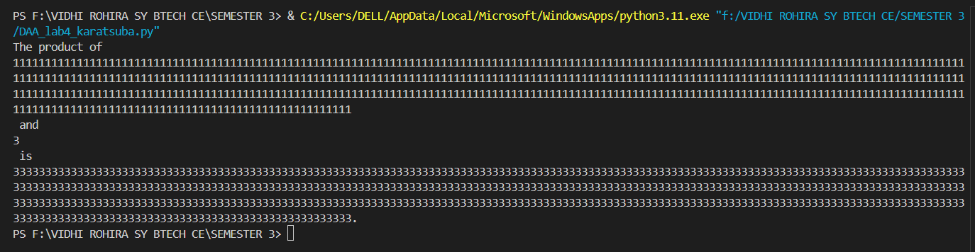

**1000-DIGIT NUMBER**

**TEST CASE 9:-**

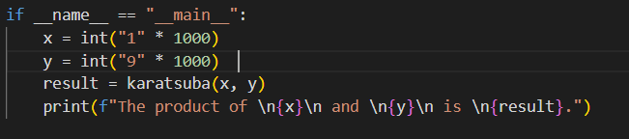

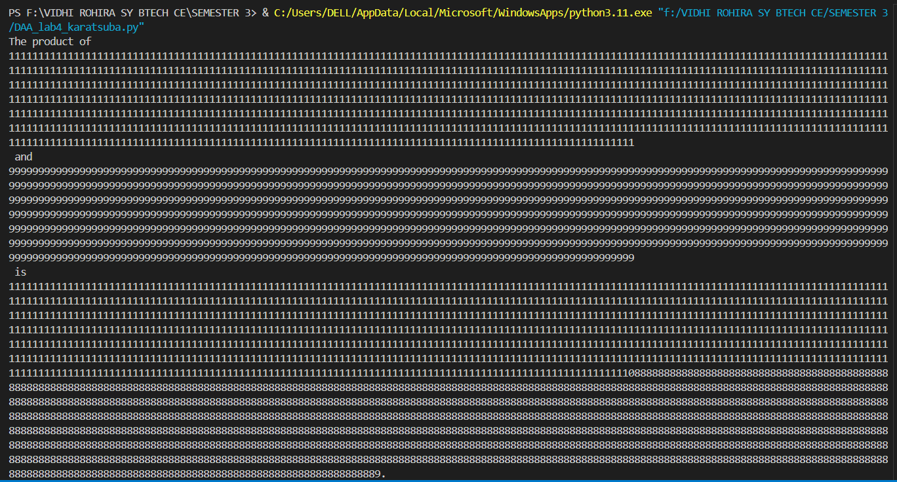

**TEST CASE 10:-**

